[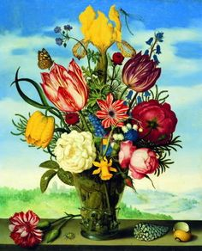](https://www.google.nl/url?sa=i&rct=j&q=&esrc=s&frm=1&source=images&cd=&cad=rja&uact=8&ved=0CAcQjRw&url=https%3A%2F%2Fwww.pinterest.com%2Famsterdamwillia%2Fcompositie-centraaldriehoekdianogaaloverall%2F&ei=-x_2VJWmHIGlUNn5gcgJ&bvm=bv.87519884,d.d24&psig=AFQjCNER3RF0h5n8UosD0b6aUUpTF8_ivg&ust=1425502514208110)[](http://www.google.nl/url?sa=i&rct=j&q=&esrc=s&frm=1&source=images&cd=&cad=rja&uact=8&ved=0CAcQjRw&url=http%3A%2F%2Fwww.beeldacademie.com%2Fcompositie.html&ei=0h_2VJrzLsmvUcOdgyA&bvm=bv.87519884,d.d24&psig=AFQjCNER3RF0h5n8UosD0b6aUUpTF8_ivg&ust=1425502514208110)

[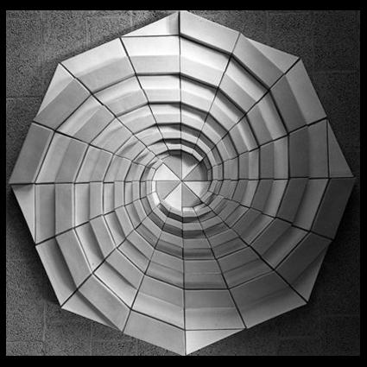](http://www.google.nl/url?sa=i&rct=j&q=&esrc=s&frm=1&source=images&cd=&cad=rja&uact=8&ved=0CAcQjRw&url=http%3A%2F%2Fwww.capriolus.nl%2Fnl%2Fcontent%2Fvaart-jan-van-der-0&ei=gCD2VNv9FYL2UsqXgpgE&bvm=bv.87519884,d.d24&psig=AFQjCNER3RF0h5n8UosD0b6aUUpTF8_ivg&ust=1425502514208110)Centraal Compositie